Portals Mill Asset register
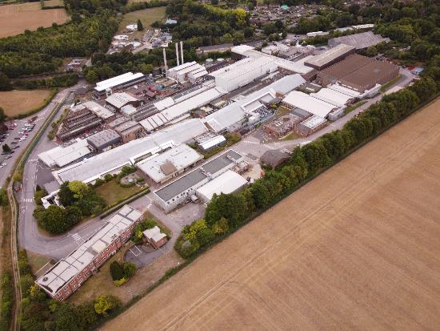
Overton Mill, Overton, Hampshire, RG25 3JG.
Portals opened Overton Mill, near to Laverstoke, in 1922. Paper making ceased at Laverstoke Mill in 1963, having transferred to the nearby and more modern Overton Mill. In 1972, Portals acquired Bathford Mill, near Bath in Somerset, which had been producing paper since 1809. In 1995, Portals were themselves acquired by De La Rue, the banknote printers, and the name ceased to be used. In 2018, De La Rue divested itself of its paper making activities, and the name Portals was again used for the newly independent business. There has been significant investment within the mill over the last 15 years any holds specialist machinery associated with banknote manufacturing.

Items included;
Refiners, Refiner Fillings, Air Compressors/blowers, Jones Breakers, Reel Splitter, Whollenburg, Pulper, Screening, Mould Manufacturing, Storage and distribution, Pumps, Controls, Gravure Coating Machines, and pallet turners.

SOLD
SOLD
SOLD
SOLD

SOLD
SOLD
SOLD
SOLD
SOLD
SOLD
SOLD
SOLD
SOLD
SOLD
SOLD
SOLD

SOLD
SOLD
SOLD

SOLD
SOLD

SOLD

Ebay
We also have a number of items for sale on our Ebay site including ABB, Siemens, Foxboro, Parker, Eurotherm, Allan Bradley, Honeywell, and many others as well as an engineering stores with a stock value of £9m.
The website is as follows : https://www.ebay.co.uk/str/horizonengineering and assets are being added daily.
If you would like to arrange a site visit to view what is on offer or need more information, we can support you.

