SRC MACHINE

Details of the SRC Machine are as follows;

Basic Material Specifications
Wet laid nonwovens + others
Thickness ranges from 350gsm – 450gsm
Minimum product tensile 100N/m

Unwind Section
Max web width 1800mm
Max rewind/unwind weight 250/300kgs
Max unwind roll diameter 1200mm
Braked unwind with load cell tension control
Automatic edge guider (+/- 50mm)
Reel lift arms on the unwind
Shaft-less unwind unit (min web width 400mm – max web width 1800mm)
Web splice and inspection table
Unwind cores i/d 76mm and 152mm chucking facilities

Nip Section
Driven draw rollers, with pneumatically actuated nip roller

Slitting Section
Rotary shear slitting (tangential)
16 individual shaft mounted female knives
16 individual pneumatic dovetail mounted shear slitting knives
Minimum slitting width 50mm
Normally slitting 300-400mm widths

Rewind Section
Simplex centre-surface rewind
Maximum rewind diameter 1200mm
Rewind mode – locked core (airshaft) – 1 off rewind airshaft 76mm
Off-loading the rewind support arms will lower to floor (similar to the Parkland system)

Rewind roll removal by pump truck with bogey arrangement as currently in use on the parkland system (not part of selling scope)
Two drive machine – one draw roller drive and one rewind roller drive
Machine speed 200mpm (maximum mechanical speed).

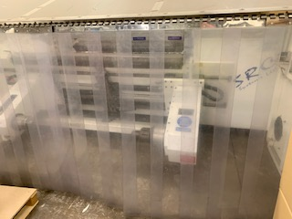

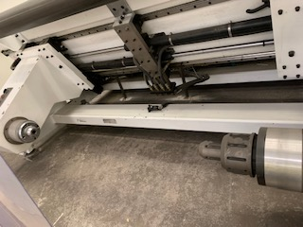

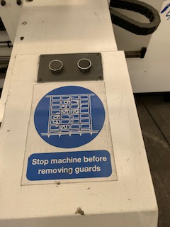

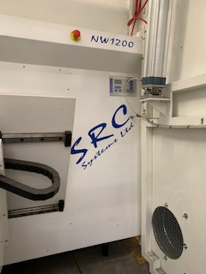
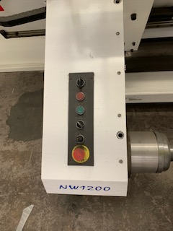

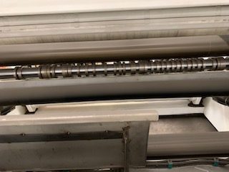

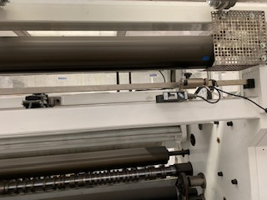

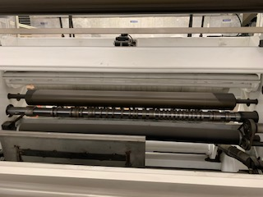
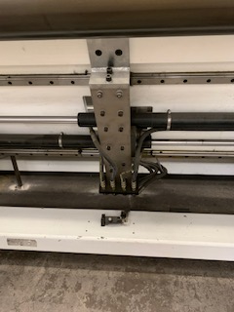

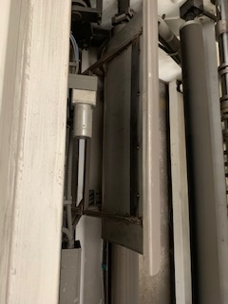
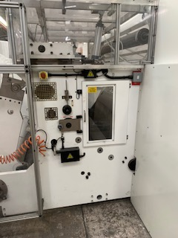

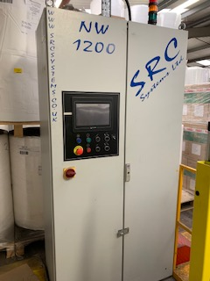

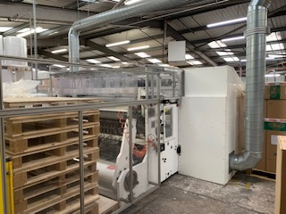

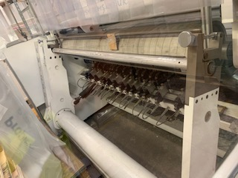

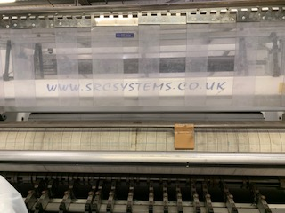

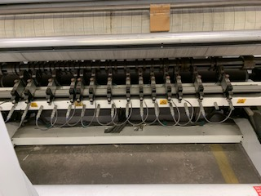

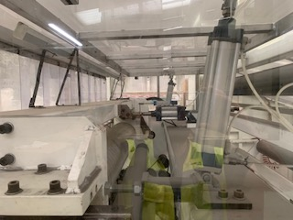

THIS INFORMATION IS THE TITLE OF JOHN WILKIE PAPER MILL SERVICES LTD AND SHOULD NOT BE COPIED OR FORWARDED TO A THIRD PARTY WITHOUT CONSENT.

FOR YOUR GENERAL INFORMATION WE HAVE TO INTIMATE THE FOLLOWING TO YOU:
This schedule has been prepared solely for the guidance of prospective purchasers and does not constitute (and at no time shall be deemed to constitute) an offer or contract or any part of an offer or contract. Additionally, no warranty is given to the accuracy of any measurements, specifications or other details whatsoever given within this schedule.
Whilst every reasonable effort has been made to verify any statement, description, or comment made within this schedule, for the avoidance of doubt it is emphasised that the purchaser must make their own enquiries and satisfy themselves.

