**Due to the Orderly Wind Down and Closure of the Overton Mill**

U

In Association with John Wilkie Papermill Services Ltd.

**FOR SALE BY TENDER**

Gravure Coating machine no.3 (Platinum Coater)

&

Gravure Coating machine no.4 (Platinum Coater)

**Viewing strictly by appointment**

**Offers Due by 4:00 pm GMT on 11th August 2023**

**to john.amor@portalsinternational.com**

**REGISTRATION & OFFER FORM**

**This form must be submitted with the machine schedules attached, together with your Banker’s confirmation of funds.**

**Company Name** ...................................................................................................................

**Company Contact Name** .....................................................................................................

**Address** .................................................................................................................

................................................................................................................................

................................................................................................................................

**Postcode / Zip Code** .............................................................................................

**Position in Company** ............................................................................................

**Office Tel No.** .........................................................................................................

**Mobile No.** ..............................................................................................................

**Email Address** .......................................................................................................

OFFERS:

***++++++++++++++++++++++++++++++++++++++***

**Item 1:**

**Gravure Coating machine no.3 Machine Offer Price (GBP) Subject to 20% VAT: £…………………………..**

***Please note:***

* ***Offers only accepted for this asset if they are greater than £100,000***

***++++++++++++++++++++++++++++++++++++++***

* **Item 2:Gravure Coating machine no.4** **Machine Offer Price (GBP) Subject to 20% VAT: £……………………………**

***Please note:***

* ***Offers only accepted for this asset if they are greater than £150,000***
* ***++++++++++++++++++++++++++++++++++++++***

**1.** U**TENDER FORM**

Please return your offer(s) by email to john.amor@portalsinternational.com. Your offer(s) should be returned no later than 4:00pm GMT, 11th August 2023.

Please complete the registration document and return with your offer, together with your Banker’s confirmation of funds unless you have already bought assets from Portals.

**2. NOTIFICATION & DEPOSIT PAYMENT**

Should you be successful in purchasing this machine, you will be sent an invoice for a 20% of this price plus VAT which is a non-refundable deposit invoice for payment within 7 working days of receipt. **Failure to complete the transfer of deposit in time will preclude the offering party**

**3. BALANCE OF PAYMENT**

Deadline for the 80% balance of payment is by 4:00pm GMT, 11th September 2023.

Once payment has been received, we will issue a ‘Paid in Full’ confirmation.

**All payments without exception should be made by Bank Transfer.**

**All Portals banking details and clearance procedures will be on your invoice.**

**4. DESCRIPTIONS**

The information contained herein as to the quality, description, etc. of the goods is provided in good faith but without obligation, and prospective purchasers must rely on their own examination of the goods.

Assets are sold under our standard terms and conditions as detailed in our invoice.

**Buyers are not entitled to any goods or other items not included in the lot descriptions attached.**

**5. WARRANTY**

All goods are sold without warranty.

**6. RELEASE OF GOODS**

No goods will be allowed to be removed until all monies owed by the Buyer have been settled in full by way of cleared funds.

**7. VALUE ADDED TAX (VAT)**

The sale of all machines are subject to the addition of VAT in accordance with the rules of HM Revenue and Customs.

VAT will be levied at the prevailing rate (currently 20%) on the bid price and charged in addition to the bid price.

Subject to the above, the two conditions under which VAT will be repaid are as follows:

**Non EC Purchasers**: VAT will be repaid upon receipt of a copy of the Bill of Lading, or other official documentation, to prove that the goods have been exported.

**Companies Registered in an EC Member State**: VAT will be repaid upon receipt of a copy of the Bill of Lading, or other official documentation, to prove that the goods have been exported.

In the event that claimants do not comply with the above terms, the VAT element will be transferred to the Seller in accordance with our standard VAT procedures.

**8. REMOVAL OF LOTS**

Final date for collection of all machinery will be 15th December 2023.

Any items not removed by this date will be deemed abandoned.

It is the Buyer’s responsibility to ensure that arrangements have been made for the professional & suitable qualified removal of all lots purchased and this will include ensuring compliance with all UK Health & Safety regulations, specifically Construction and Design Management (CDM) 2015.

**Gravure Coating machine no.3**

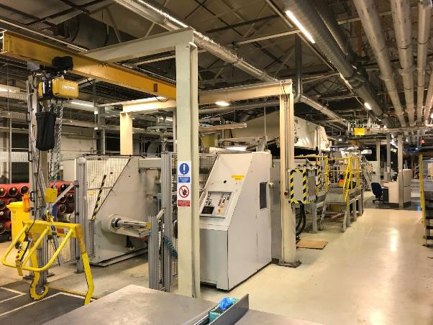

Emerson & Renwick coating machine, built in 2006 with upgrade to unwind tracker in 2020. Web width min 450mm, max 950mm, max speed of 170m/min, tension range of 50N – 500N, capable of process banknote paper to 85-90gsm. Dry coating weight range of 2-3 gsm per side with solids content range of 15-40%. Unwind diameter of min 300m, max1250mm with maximum weight of 1100kg. The purpose of the equipment is to apply a surface coating to a paper substrate. The coating is water based. Coating can be applied to one or both sides of the substrate in a single pass through the machine. The proposed coating process is offset differential gravure with the facility to coat in forward and reverse directions. Coating will be applied and dried sequentially to both

|  |  |  |  |  |  |  |  |
| --- | --- | --- | --- | --- | --- | --- | --- |
| ID | Section | Assets | Description | Year | Make | Model | Photos |
| 471 | Approach | Reel load Crane | Transfers reel from floor to unwind | 2006 | Emerson & Renwick (various) |  |  |
| 472 | Unwind | Unwind unit | Single position unit, non- continuous operation during web changes. Web support, tension control system and web guiding system | 2006 | Emerson & Renwick (various) |  |  |
| 473 | Unwind | Web guiding system | Watermark guiding system designed to guide web though machine to within 0.5mm accuracy | 2020 | E&L | OL91 |  |
| 474 | Coating | Coating station | Designed for forwards and reverse gravure process. Gravure, Applicator and backing rollers. Applicator has Changeable sleeves and has backing roll cleaning system | 2006 | Emerson & Renwick (various) |  |  |
| 475 | Drying system |  | The two, single zone, air-float dryers supplied are  designed to dry the water-based coating applied to a continuous web of  currency paper. The drying is achieved by heated air in a ‘non-contact’  process in each of the similar dryers. | 2006 | Spooner |  |  |
| 476 | Cooling system | Cooling no.1 | To provide moisture back into paper. Diameter is 150mm, made from a single shell mild steel tube coated in neoprene 70o, with a  face width of 1050mm. | 2006 | Emerson & Renwick (various) |  |  |
| 477 | Cooling system | Cooling no.2 | To provide moisture back into paper. Diameter is 300mm, single design for mono-flow cooling with mild steel tube and ends, hard  chrome platted 150 microns thick 0.4 Ra, face width is 1050mm. | 2006 | Emerson & Renwick (various) |  |  |
| 478 | Nip Calendar |  | Applies a pressure of between 50 – 200PLI across the sheet width on both sides. Three independent Kadant doctor blade assemblies are installed at each of the three rollers  positions for removal of loose particulate. | 2006 | Emerson & Renwick (various) |  |  |
| 479 | Rewind |  | Single position unit, non- continuous operation during web changes. Web support, tension control system and web guiding system | 2006 | Emerson & Renwick (various) Fife tidland guiding | SYMAT 300A |  |
| 480 | Reel unload truck assembly |  | Unloads web from rewind to floor level | 2006 |  |  |  |
| 481 | Power and controls |  | Siemens Motor gearboxes with SSD parker 690 series drives and siemens S7 300 series PLC’s. 415V 400A | 2006 | Siemens & SSD | S7 300 seriesies690 series (older version) |  |
| 482 | Coating Kitchen and delivery system |  | Mixing and side tanks used to mix Neorez, cross linker and De foaming. Pumps. Side tank is able to hold a maximum volume of 200 litres and is bunded to hold a volume of  110% of the total possible volume. Dosing system used to provide continuous feed to machine | 2006 | Emerson & Renwick (various) |  |  |
| 483 | Ink marking | Domino printer | Ink marking Domino A420i printer | 2020 | Domino | A420i |  |

sides of the web with the web path through coater number 2 configured for application to the bottom side passing to the dryer. Drives on: LH side, Operator controls on: RH, Main power cabinets on: LH



**Gravure Coating machine no.4**

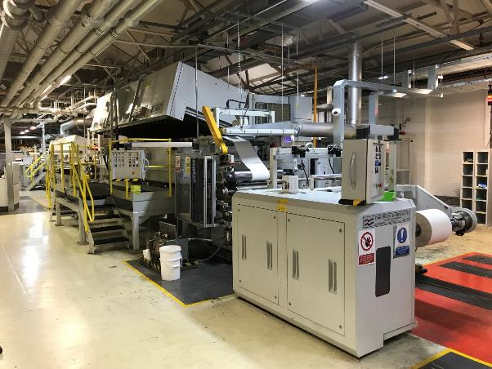

Emerson & Renwick coating machine, built in 2015 at a cost of £3.2m. Web width min 450mm, max 950mm, max speed of 190m/min, tension range of 70N – 700N, capable of process banknote paper to 80-120gsm. Dry coating weight range of 2-4gsm per side with solids content range of 20%. Unwind diameter of min 300m, max1500mm with maximum weight of 1250kg. The purpose of the tandem coating line is to apply a surface coating on to a paper substrate. The coating can be applied to one or both sides of the substrate in one single pass through the machine; the coating is a water based

solution. Coating will be applied and dried sequentially to both sides of the web with the web path

through coater number 2 configured for application to the bottom side passing to the dryer. Drives on: RH side

Operator controls on: LH Main power cabinets on: RH



|  |  |  |  |  |  |  |  |  |
| --- | --- | --- | --- | --- | --- | --- | --- | --- |
| ID | Section | Assets | Description | Year | | Make | Model | Photos |
| 484 | Approach | Scissor lift | Used to transfer material reel from floor level to transfer shaft of reel truck | | 2015 | Emerson & Renwick (various) |  |  |
| 485 | Approach | Reel load truck assembly | Transfers reel from scissor lift to unwind | | 2015 | Emerson & Renwick (various) | ……. |  |
| 486 | Unwind | Unwind unit | Single position unit, non- continuous operation during web changes. Web support, tension control system and web guiding system | | 2015 | Emerson & Renwick (various) |  |  |
| 487 | Unwind | Web guiding system | Watermark guiding system designed to guide web though machine to within 0.5mm accuracy | | 2015 | E&L | Type DR 3111 |  |
| 488 | Coating | Coating station | Designed for forwards and reverse gravure process. Gravure, Applicator and backing rollers. Applicator has Changeable sleeves and has backing roll cleaning system | | 2015 | Emerson & Renwick (various) |  |  |
| 489 | Drying system | Drying | The two, single zone, air-float dryers supplied are  designed to dry the water-based coating applied to a continuous web of  currency paper. The drying is achieved by heated air in a ‘non-contact’  process in each of the similar dryers. | | 2015 | Spooner |  |  |
| 490 | Cooling system | Cooling no.1 | To provide moisture back into paper. Diameter is 150mm, made from a single shell mild steel tube coated in neoprene 70o, with a  face width of 1050mm. | | 2015 | Emerson & Renwick (various) |  |  |
| 491 | Cooling system | Cooling no.2 | To provide moisture back into paper. Diameter is 300mm, single design for mono-flow cooling with mild steel tube and ends, hard  chrome platted 150 microns thick 0.4 Ra, face width is 1050mm. | | 2015 | Emerson & Renwick (various) |  |  |
| 492 | Double Nip Calendar |  | Applies a pressure of between 50 – 200PLI across the sheet width on both sides. Three independent Kadant doctor blade assemblies are installed at each of the three rollers  positions for removal of loose particulate. | | 2015 | Emerson & Renwick (various) |  |  |
| 493 | Rewind |  | Single position unit, non- continuous operation during web changes. Web support, tension control system and web guiding system | | 2015 | Emerson & Renwick (various) |  |  |
| 494 | Reel unload truck assembly |  | Single position unit, non- continuous operation during web changes. Web support, tension control system and web guiding system | | 2015 | Emerson & Renwick (various) |  |  |
| 495 | Power and controls |  | Siemens Motor gearboxes with SSD parker 690 series drives and siemens S7 300 series PLC’s. 415V 400A | | 2015 | Emerson & Renwick (various) |  |  |
| 496 | Coating Kitchen and delivery system |  | Mixing and side tanks used to mix Neorez, cross linker and De foaming. Pumps. Side tank is able to hold a maximum volume of 200 litres and is bunded to hold a volume of  110% of the total possible volume. Dosing system used to provide continuous feed to machine | | 2015 | Emerson & Renwick (various) |  |  |
| 497 | Ink marking | Domino printer | Ink marking Domino A420i printer | | 2015 | Domino | A420i |  |

**THIS INFORMATION IS THE TITLE OF JOHN WILKIE PAPERMILL SERVICES LTD AND SHOULD NOT BE COPIED OR FORWARDED TO A THIRD PARTY WITHOUT CONSENT.**

**FOR YOUR GENERAL INFORMATION WE HAVE TO INTIMATE THE FOLLOWING TO YOU:**

**This schedule has been prepared solely for the guidance of prospective purchasers and does not constitute (and at no time shall be deemed to constitute) an offer or contract or any part of an offer or contract. Additionally, no warranty is given to the accuracy of any measurements, specifications or other details whatsoever given within this schedule.**

**Whilst every reasonable effort has been made to verify any statement, description, or comment made within this schedule, for the avoidance of doubt it is emphasised that the purchaser must make their own enquiries and satisfy themselves.**