SPARES BROCHURE_Refiners and Vacuums
ITEM # | Value | Assets | Description | Make | Model
Refvac_1 | £10,000 | S/C 001800 Nash Vacuum Pump 904 | 904M2 ME11632 - NASH VACUUM PUMP PM2 & PM3 PICKUP AND HOLDING ZONE VAC PUMP. | Nash | 904M2 ME11632 | 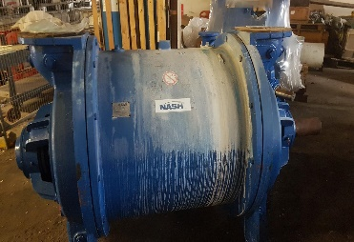
Refvac_2 | £17,000 | S/C3001200 NASH VACUUM PUMP CL2002 | NASH VACUUM PUMP CL3002 Serial No ME16089 YEAR2022 | NASH | CL3002 | 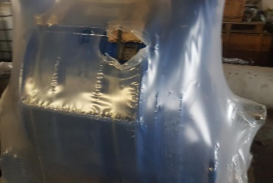
Refvac_3 | £14,000 | S/C1542600 NASH VACUUM PUMP CL2002 | NASH VACUUM PUMP CL2002 Serial No 014019 YEAR2012 | NASH | CL2002 | 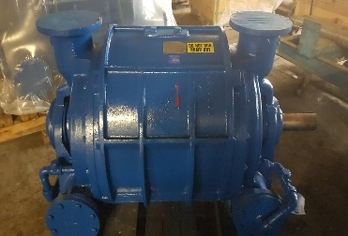
Refvac_4 | £25,000 | 2 from Cleansheet | REFINER JYLHA CONFLO JC-01 with CONE FILLING 'LM' PATTERN | SUNDS | JC-01 | 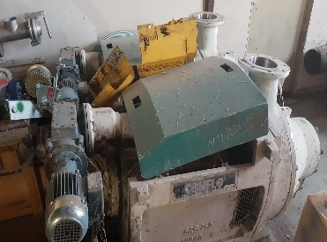
Refvac_5 | £4,000 | S/C1800052 | SCREEN BASKET ST.ST MAT.NO.1.4436 PLATE THICKNESS 5.0MM INNER DIA 412MM HEIGHT 420MM SLOT WIDTH 0.30MM ELECTRO POLISHED INCL REINFORCING RINGS! PM2 VAT TERTIARY SCREEN FINCKH VERT REP: | FINCKH |  | 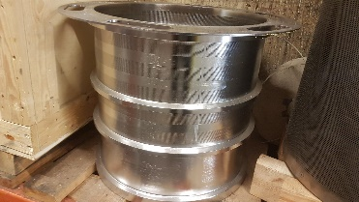
Refvac_6 | £4,000 | S/C1670507 | SCREEN BASKET FOR FINCKH VERTICAL SCREEN MODEL O. HF NO:1188 SLOT WIDTH 0.30MM FORM B REP: PM1 FINCKH VERTICAL SECOND STAGE SCREEN | FINCKH | MODEL O | 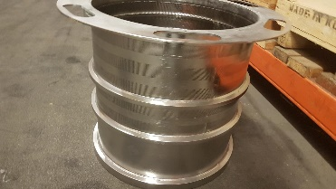
Refvac_7 | £ 11,000 | S/C1670505 SCREEN BASKET FOR VERTICAL SCREEN MODEL K100L 0.30 MM. SLOT WIDTH | SCREEN BASKET FOR VERTICAL SCREEN MODEL K100L 0.30 MM. SLOT WIDTH FORM A. PM1 FINCKH PRIMARY SCREEN MODEL K100L | FINCKH | K100L | 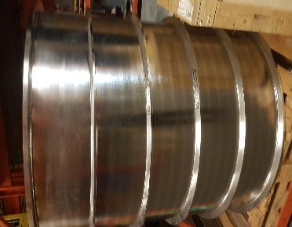
Refvac_8 | £3,000 | S/C1800049 | SCREEN BASKET ST.ST MAT.NO. 1.4436 PLATE THICKNESS 5.0MM INNER DIA 412MM HEIGHT 420MM SLOT WIDTH 0.25MM ELECTRO POLISHED INCL REINF[CCING RINGS *PM2 FORMER SECOND STAGE SCREEN FINCKH MODEL H04 | FINCKH | MODEL H04 | 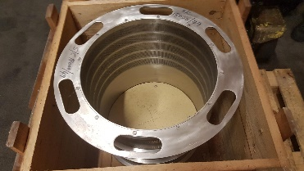
Refvac_9 | £6,000 | S/C3000300 | SCREEN BASKET SLOT WIDTH 0.15MM FOR FINCKH HICO SCREEN MODEL IE HS, HF#245. QUOTE 36.204 (26.6.95) REP: PM3 FINCKH FORMER SECONDARY SCREEN MODEL IE HS | FINCKH | MODEL IE HS | 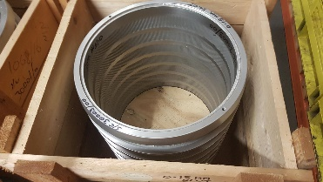
Refvac_10 | £6,000 | S/C3000100 | SCREEN BASKET SLOT WIDTH 0.20MM FOR FINCKH HICO SCREENS MODEL IHS, HF#242 & IEHS, HF#243. QUOTE 36.203 (26.6.95) REP: PM3 FINCKH VAT SECONDARY & TERTIARY SCREEN MODEL IHS & IEHS | FINCKH | MODEL IHS & IEHS | 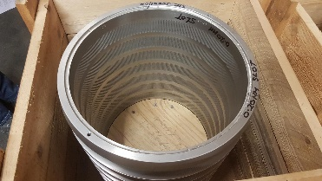
Refvac_11 | £ 33,000 | S/C1800056 | SCREEN BASKET ST.ST MAT.NO.1.4436 PLATE THICKNESS 4.0MM INNER DIA 790MM HEIGHT 1190MM SLOT WIDTH 0.30MM ELECTRO POLISHED INCL REINFORCING RINGS REP: PM2 VAT PRIMARY SCREENS FINCKH VERTICAL SCREEN MODEL K80L | FINCKH | MODEL K80L | 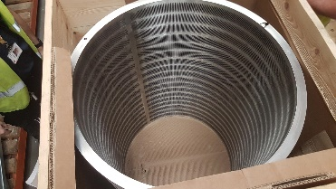
Refvac_12 | £ 8,000 | S/C1800050 | SCREEN BASKET ST.ST MAT.NO.1.4436 PLATE THICKNESS 4.0MM INNER DIA 590MM HEIGHT 980MM SLOT WIDTH 0.25MM ELECTRO POLISHED INCL REINFORCING RINGS PM2 FORMER PRIMARY SCREEN FINCKH VERTICAL SCREEN K60L | FINCKH | SCREEN K60L | 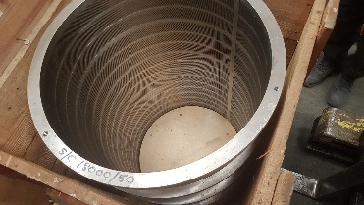
Refvac_13 | £ 4,000 | S/C1800054 | SCREEN BASKET ST.ST MAT.NO.1.4436 PLATE THICKNESS 4.0MM INNER DIA 412MM HEIGHT 620MM SLOT WIDTH 0.30MM ELECTRO POLISHED INCL REINFORCING RINGS. REP: PM2 VAT SECOND STAGE SCREEN FINCKH MODEL K42L | FINCKH | MODEL K42L | 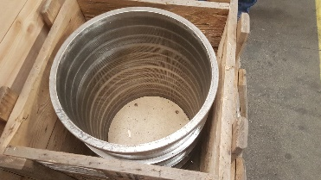
Refvac_14 | £6,000 | S/C1800008 | CONE FILLING. PATTERN 'LM' (POLISHED) SUNDS REFINER.JYLHA JC-01 | SUNDS | JC 01 LM FILLINGS | 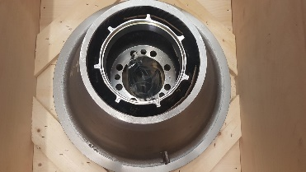
Refvac_15 | £ 9,000 | S/C1800029 | CONE FILLING TM (POLISHED) ROTOR:JC01RTM-SJP. STATOR:JC01STM-SJP. | SUNDS | JC 01 TM FILLINGS | 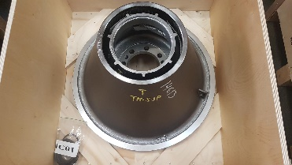
Refvac_16 | £9,000 | S/C3062003 | CONE FILLING SUNDS JC01RTC3K - SJP + COATING (ROTOR) JC01STC3K | SUNDS | JC 01 STC3K FILLINGS | 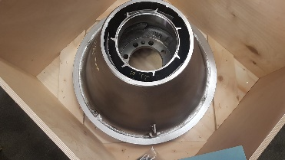
Refvac_17 | £ 7,000 | S/C1800140 | CONE FILLINGS. SPECIAL SC PATTERN (EVERY OTHER BAR REMOVED) ROTOR SC.JC01RSCH-SJ.STATOR SC.JC01SSCH-SJ | SUNDS | JC 01 SC FILLINGS | 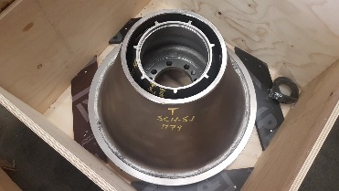
Refvac_18 | £6,000 | S/C3062200 | CONE FILLING LF FOR SUNDS JC-01 REFINER COMPRISING ROTOR & STATOR | SUNDS | JC 01 LF FILLINGS | 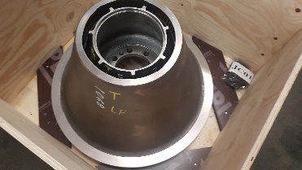
Refvac_19 | £6,000 | Not Stock but new | Rotor JC01RMM10ZSJ-CLA with Stator JC01SMM10ZSJ-CLA. | SUNDS | JC 01 MMZ FILLINGS | 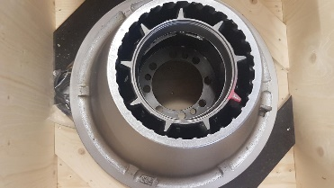
Refvac_20 | £9,000 | S/C3062003 | CONE FILLING SUNDS JC01RTC3K - SJP + COATING (ROTOR) JC01STC3K | SUNDS | JC 01 STC3K FILLINGS | 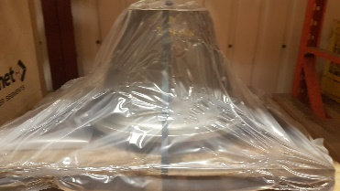
Refvac_21 | £9,000 | S/C3062003 | CONE FILLING SUNDS JC01RTC3K - SJP + COATING (ROTOR) JC01STC3K | SUNDS | JC 01 STC3K FILLINGS
Refvac_22 | £ 7,000 | S/C1800140 | CONE FILLINGS. SPECIAL SC PATTERN (EVERY OTHER BAR REMOVED) ROTOR SC.JC01RSCH-SJ.STATOR SC.JC01SSCH-SJ | SUNDS | JC 01 SC FILLINGS
Refvac_23 | Box No1  £3,000 | USED CONES – BAR HEIGHT AT 6mm | CONE FILLING LF FOR SUNDS JC-01 REFINER COMPRISING ROTOR & STATOR | SUNDS | JC 01 LF FILLINGS | 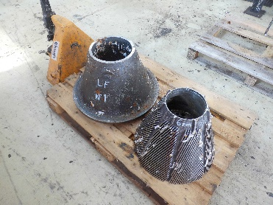
Refvac_24 | Box No2  £3,000 | USED CONES – BAR HEIGHT AT 10mm | CONE FILLING SUNDS JC01RTC3K - SJP + COATING (ROTOR) JC01STC3K | SUNDS | JC 01 STC3K FILLINGS | 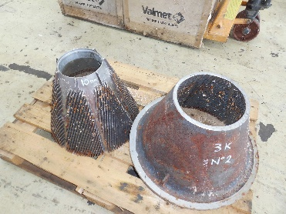
Refvac_25 | Box No3  £3,000 | USED CONES – BAR HEIGHT AT 6mm | CONE FILLING SUNDS JC01RTC3K - SJP + COATING (ROTOR) JC01STC3K | SUNDS | JC 01 STC3K FILLINGS | 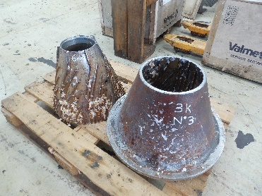
Refvac_26 | Box No4  £3,000 | USED CONES – BAR HEIGHT AT 6mm | CONE FILLINGS. SPECIAL SC PATTERN (EVERY OTHER BAR REMOVED) ROTOR SC.JC01RSCH-SJ.STATOR SC.JC01SSCH-SJ | SUNDS | JC 01 SC FILLINGS | 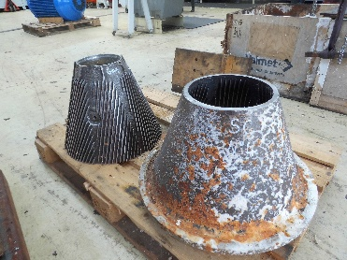
Refvac_27 | Box No5  £3,000 | USED CONES – BAR HEIGHT AT 7mm | CONE FILLING TM (POLISHED) ROTOR:JC01RTM-SJP. STATOR:JC01STM-SJP. | SUNDS | JC 01 TM FILLINGS | 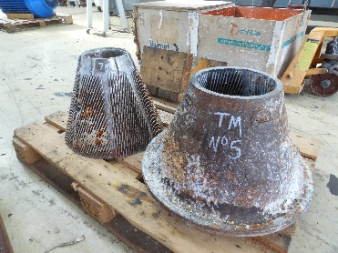
Refvac_28 | Box No6  £3,000 | USED CONES – BAR HEIGHT AT 8mm | CONE FILLING SUNDS JC01RTC3K - SJP + COATING (ROTOR) JC01STC3K | SUNDS | JC 01 STC3 FILLINGS | 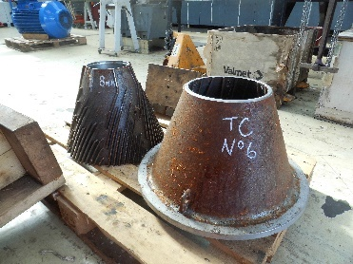
Refvac_29 | Box No7  £3,000 | USED CONES – BAR HEIGHT AT 8mm | CONE FILLINGS. SPECIAL SC PATTERN (EVERY OTHER BAR REMOVED) ROTOR SC.JC01RSCH-SJ.STATOR SC.JC01SSCH-SJ | SUNDS | JC 01 SC FILLINGS | 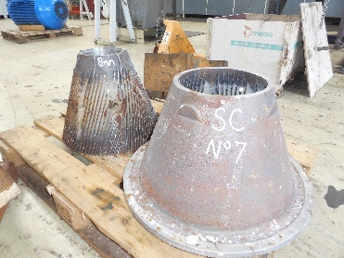
Refvac_30 | Box No8  £3,000 | USED CONES – BAR HEIGHT AT 8mm | CONE FILLING SUNDS JC01RTC3K - SJP + COATING (ROTOR) JC01STC3K | SUNDS | JC 01 STC3K FILLINGS | 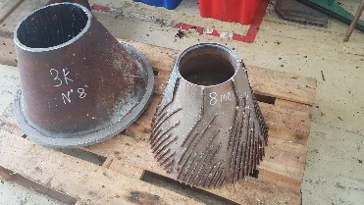
Refvac_31 | Box No9  £3,000 | USED CONES – BAR HEIGHT AT 7mm | CONE FILLINGS. SPECIAL SC PATTERN (EVERY OTHER BAR REMOVED) ROTOR SC.JC01RSCH-SJ.STATOR SC.JC01SSCH-SJ | SUNDS | JC 01 SC FILLINGS | 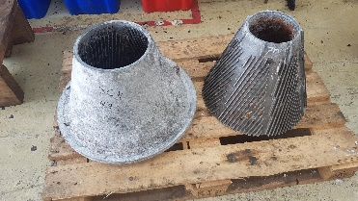
Refvac_32 | Box No10  £3,000 | USED CONES – BAR HEIGHT AT 8mm | CONE FILLINGS. SPECIAL SC PATTERN (EVERY OTHER BAR REMOVED) ROTOR SC.JC01RSCH-SJ.STATOR SC.JC01SSCH-SJ | SUNDS | JC 01 SC FILLINGS | 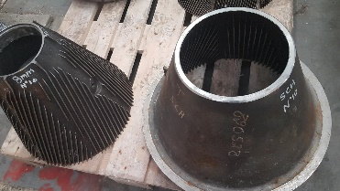
Refvac_33 | Box No11  £3,000 | USED CONES – BAR HEIGHT AT 8mm | CONE FILLING SUNDS JC01RTC3K - SJP + COATING (ROTOR) JC01STC3K | SUNDS | JC 01 STC3K FILLINGS | 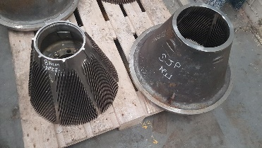
Refvac_34 | Box No102  £3,000 | USED CONES – BAR HEIGHT AT 7mm | CONE FILLINGS. SPECIAL SC PATTERN (EVERY OTHER BAR REMOVED) ROTOR SC.JC01RSCH-SJ.STATOR SC.JC01SSCH-SJ | SUNDS | JC 01 SC FILLINGS | 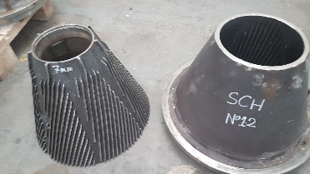
Refvac_35 | Box No13 | USED CONES – BAR HEIGHT AT 8mm | ?? | SUNDS | JC 01 SF FILLINGS | 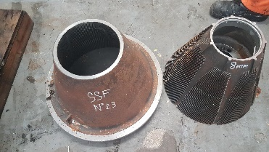
Refvac_36 | Box No14  £3,000 | USED CONES – BAR HEIGHT AT 5mm | CONE FILLING SUNDS JC01RTC3K - SJP + COATING (ROTOR) JC01STC3K | SUNDS | JC 01 STC3K FILLINGS | 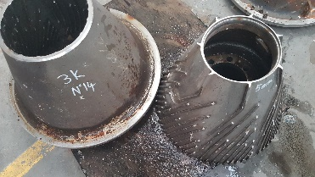
Refvac_37 | Box No15  £3,000 | USED CONES – BAR HEIGHT AT 11mm | ?? | SUNDS | JC 01 FILLINGS | 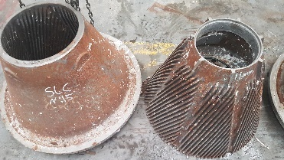
Refvac_38 | Box No16  £3,000 | USED CONES – BAR HEIGHT AT 7mm | CONE FILLING SUNDS JC01RTC3K - SJP + COATING (ROTOR) JC01STC3K | SUNDS | JC 01 STC3K FILLINGS | 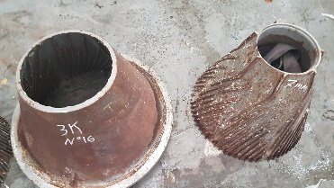
Refvac_39 | Box No17  £3,000 | USED CONES – BAR HEIGHT AT 10mm | CONE FILLING SUNDS JC01RTC3K - SJP + COATING (ROTOR) JC01STC3K | SUNDS | JC 01 STC3K FILLINGS | 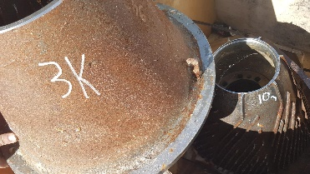
Refvac_40 | Box No18  £3,000 | USED CONES – BAR HEIGHT AT 4mm very worn | CONE FILLINGS. SPECIAL SC PATTERN (EVERY OTHER BAR REMOVED) ROTOR SC.JC01RSCH-SJ.STATOR SC.JC01SSCH-SJ | SUNDS | JC 01 SC FILLINGS | 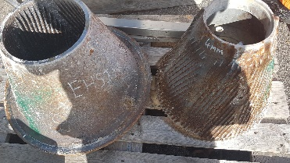
Refvac_41 | £2,000 | S/C1577905 TWO SETS | DISCS FOR 12IN. DD REFINER 1.062IN.THICK(NEW) 0.6875IN.(MIN) NO.1 STATIONERY 3.2.3-5 DEG. NO. 2 ROTATING 3.2.3.+12.5 DEG. NO. 3 ROTATING 3.2.3.+12.5 DEG. NO. 4 STATIONERY 3.2.3-5DEG | JONES | DISC 12INFOR D.D.REFINER | 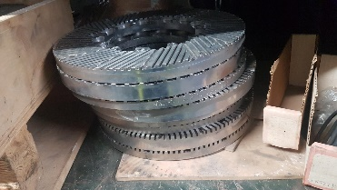
Refvac_42 | £2,000 | S/C1577933 | DISCS FOR JONES 14IN. DOUBLE D REFINER CONSISTING OF NO.1 3.2.3 +5 DEG. NO.2 3.2.3. +15 DEG. NO.3 3.2.3. +15 DEG. NO.4 3.2.3. +5 DEG. THICKNESS NEW 1.062IN.(MIN)RECUT 0.6875 14 IN. D.D REFINER. RECUT | JONES | DISC FOR JONES 14IN. DD REFINER | 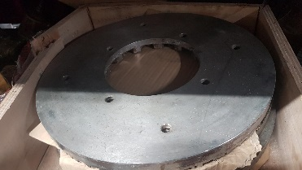
Refvac_43 | £ 15,000 | S/C1606222 | PLUG AND SHELL FILLING.PT.NO JCL101RB-SJ ROTOR B FOR CLAFLIN 101 F1 & JCL101SB-SJ STATOR B FOR CLAFLIN B F1 & 426927T BOLTS (2 OFF) FOR CLAFLIN F1 8 DEG ANGLE **CLAFLIN REFINERS. (650KILO) | VALMET TECHNOLOGIES | PLUG & SHELL FILLING PT.JCL101RB-SJ | 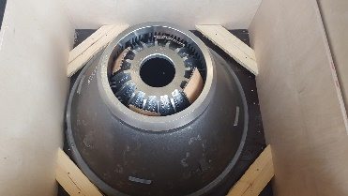
Refvac_44 | £ 15,000 | Non Stock | PLUG AND SHELL FILLING.PT.NO JCL101RB-SJ ROTOR B FOR CLAFLIN 101 F1 & JCL101SB-SJ STATOR B FOR CLAFLIN B F1 & 426927T BOLTS (2 OFF) FOR CLAFLIN F1 8 DEG ANGLE **CLAFLIN REFINERS. (650KILO) | VALMET TECHNOLOGIES | PLUG & SHELL FILLING PT.JCL101RB-SJ | 