Mould Cylinders ASSET BROCHURE
Ref | Value | Section | Assets | Description | Year | Supplier | Model | Photo
ECM_1 | £150,000 for 2 | Vat mould cylinders | WH mould Cylinder chassis | Longitudinal bars  Chassis width: 2838  Cover Face width: 2778  Bearing centres:  Weight  an expansion range of 220mm over the diameter  Grid Plate change time of less than one hour achievable  Each Grid Plate up to 70mm expansion  The expansion range can be achieved on one central body  Accuracies of less than 0.2mm deflection on the diameter  Machine direction top fins reducing the paddling effect | 2011 | Woolard and Henry |  | 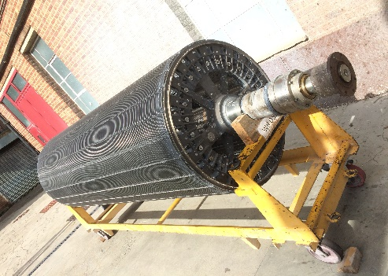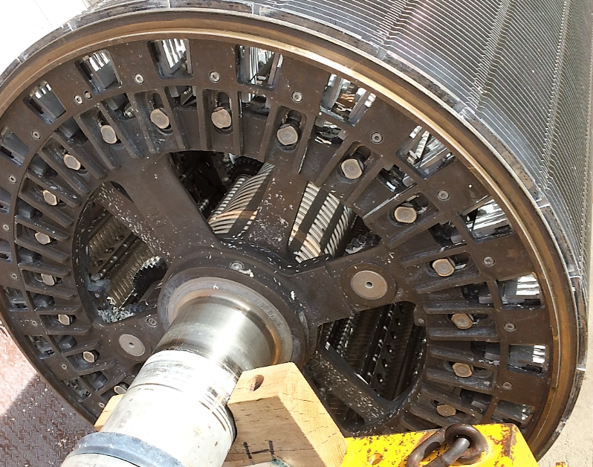
ECM_2 | £50,000 | Vat mould cylinders | Grid set x4 | Grid set for chassis  Expansion range |  | Woolard & Henry | A: 3063 – 3283  B: 3227 – 3456  C: 3424 – 3591  D: 3591- 3757 | 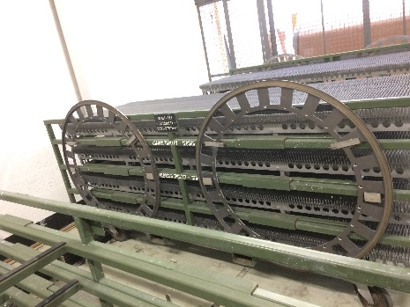
ECM_3 | £150,000 for both | Vat mould cylinders | Voith Cylinder mould x 2of | Voith Expanding cylinder  2 sets of expanding bellows  Accuracy of  Chassis width  Face width  Bearing centres  Weight | 2005 | Voith |  | 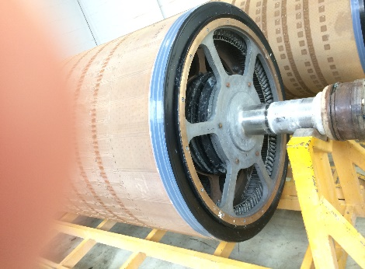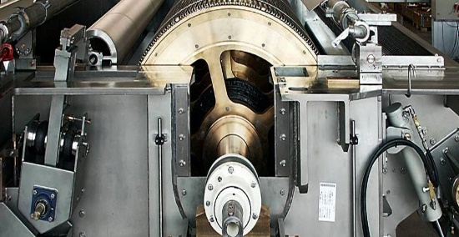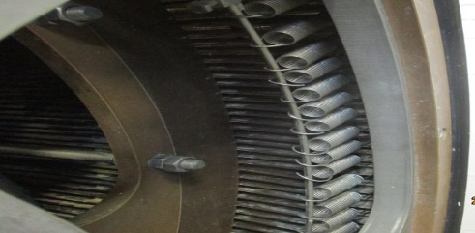
ECM_4 | £50,000 for all | Vat mould cylinders | Ring sets | 8 sets of expanding rings  2 x set of B range  2 x set of F range  Ring sets bars held in by springs  Central expansion design |  | Voith | A: 3244 – 3355  B: 3316 - 3400  C: 3396 - 3472  D: 3473 - 3544  E: 3545 - 3641  F: 3618 - 3689 | 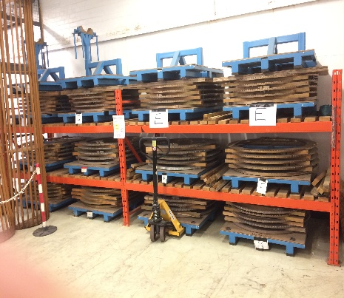
ECM_5 | £150,000 for 5 | Vat mould cylinders x5 | Expanding cylinder mould ( ECM) | Phosphor bronze expanding cylinder.  Cylinder width: 2770  Cover Face width: 2720  Bearing centres  Weight | 1981 | Perrot Aubertin | PA20: 3090- 3320  PA21: 3090 -3320  PA23: 3274- 3530  PA25: 3500- 3756  PA26: 3500- 3756 | 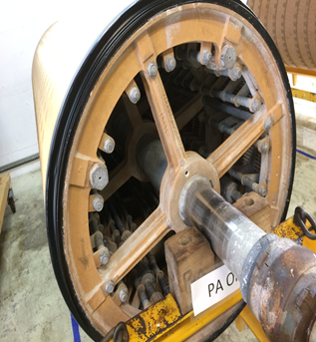
ECM_6 | £30,000 | Vat mould cylinders | Expanding cylinder mould (ECM) | Phosphor bronze expanding cylinder.  Cylinder width2770  Cover Face width 2720  Bearing centres  Weight | 1994 | Perrott Aubertin | PA19: 3090- 3320
ECM_7 | £15,000 | Vat mould cylinders | Expanding Cylinder Mould (ECM) | Cylinder incomplete | 1981 | Perrot Aubertin | Pa24: 3500- 3756 | 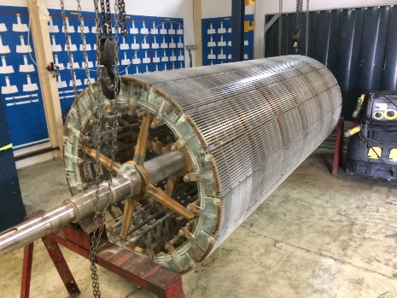
 |  | Vat mould cylinders | Expanding Cylinder Mould | Cylinder incomplete | ? | Perrott Aubertin | PA4: 3403 - 3606 | 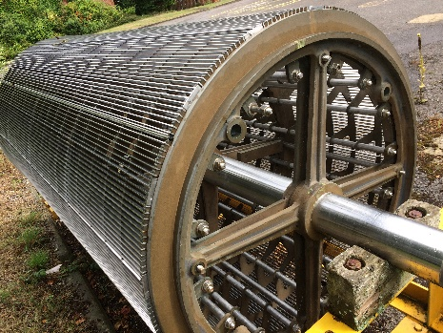
ECM_8 | £5,000 | Vat Mould cylinders | Scroll rings | Cast end rings with scoll for adjusting the cylinder circumference |  | Perrot Aubertin |  | 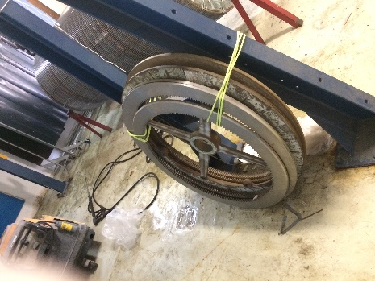
ECM_9 | £30,000 for both | Vat mould cylinders | Expanding Cylinder Moulds | H1 & H2 are ex Hawkinsville moulds – slightly narrow face but fitted with extension rings to fit PM1/2/3. |  |  | H1: 3403 - 3610  H2: 3403 - 3610 | 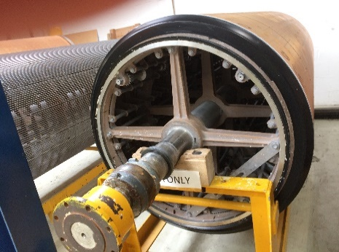
ECM_10 | £10,000 | Vat mould cylinders |  | Fixed circumference lattice constrcuction  diagonal wire seams  1 with stainless cloth covering  1 with phosphor bronze plain cloth covering |  | Dougsen | D3: 3497  D6: 3469 | 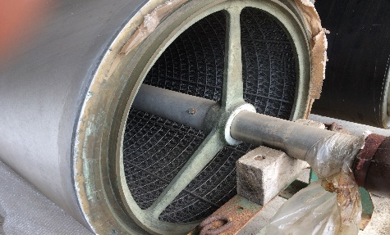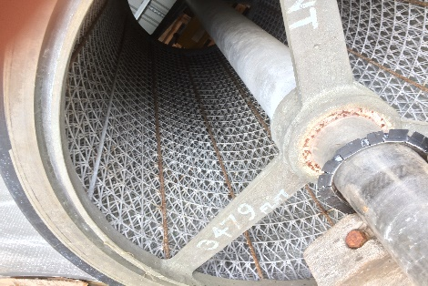
ECM_11 | £10,000 | Former ply cylinder |  | Dimensions  2 Layers of cloth  Mesh size 5 wire diagonal seam  Circumference 3927mm  Face width: |  |  | In mould repair shop | 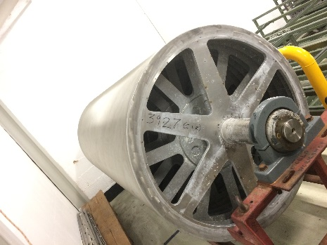
ECM_12 | £10,000 | Former ply cylinder |  | Dimensions  2 Layers of cloth  Mesh size 5 wire diagonal seam | ? | Who is make | Spre cylinders
ECM_13 | £5,000 | Former ply cylinder | 2 cylinders | Face width 2798  Face width 2795  Circumference 3927  Requires new face cloth and overhaul |  | CHR Wandel | 37462  37499 | 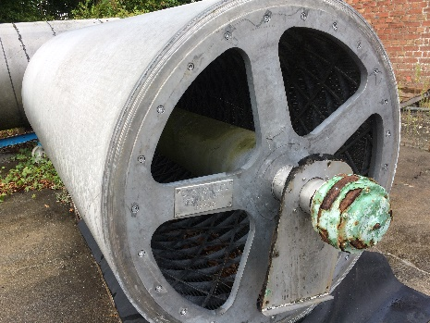
ECM_14 | £5,000 | Dandy Roll |  | Accuracy of  Chassis  Need to take out box  Face width  Bearing centres  Weight |  | Woolard & Henry |  | 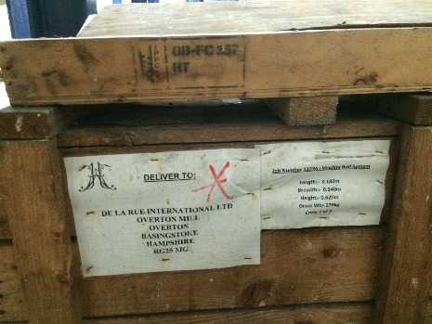
ECM_15 | £1,000 | Expanding cylinder moulds | Expanding cylinder torque tightening device |  |  |  |  | 