SPARES BROCHURE
ID | Value | Machine | Description | Make | Model | Photo
771 | £14,000 | s/c 001800 nash vacuum pump 904 | 904m2 me11632 - nash vacuum pump pm2 & pm3 pickup and holding zone vac pump. | nash | 904m2 me11632 | 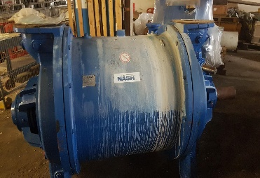
772  UNDER OFFER  REF D | £17,000 | s/c3001200 nash vacuum pump cl2002 | nash vacuum pump cl3002 serial no me16089 year2022 | nash | cl3002 | 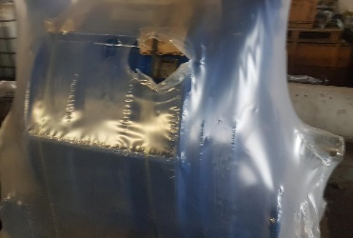
773  UNDER OFFER  REF D | £9,000 | s/c1542600 nash vacuum pump cl2002 | nash vacuum pump cl2002 serial no 014019 year2012 | nash | cl2002 | 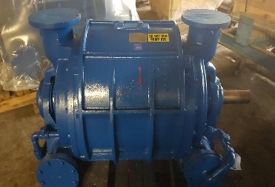
774 | £5000 | s/c1323504 pump nash vacuum type sc7 | vacuum pump nash model sc7 liquid. ring in cast iron. as test no.92e7553 & 95e0485. 795rpm. | nash | sc7 | 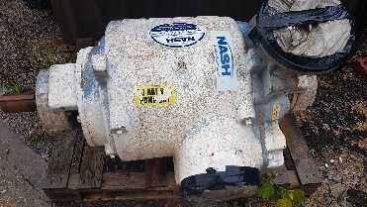
775 | £5000 | s/c1323302 pump siemens elmo type 2ba 3318-4a | siemens elmo vacuum pump type 2ba 3318-4a. as nr n54778 1v | siemens | siemens elmo type 2ba 3318-4a | 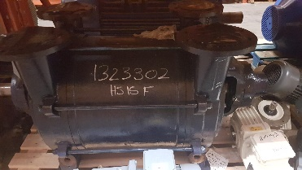
776 | £5000 | s/c1323513 pump vacuum cl402 nvp in ci | vacuum pump cl402 nvp in ci construction no 84e 7942 & 89e 3688 c/w inlet wire screen | nash | cl402 | 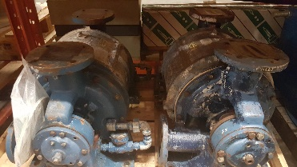
777 | £3000 | s/c1541403 pump nash vectra sx30 | nash vacuum pump vectra sx30 cast iron/cast iron stainless steel lobe/ stainless steel rotor construction antern design built onto a 5.5kw flanged motor complete with coupling | nash | sx30 | 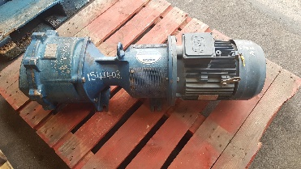
778 | £3000 | s/c3001000 pump nash vacuum type sc3 | nash liquid ring vacuum pump type sc3/e4079 nodular iron with bareshaft extension.rep: (nash no's. 95e0488, 95e0486, 95e0487 & 95e0773.) | nash | sc3 | 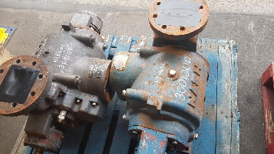
779  ONE  UNDER OFFER  REF D  ONE REMAINING | £25,000 | 2 from cleansheet | refiner jylha conflo jc-01 with cone filling 'lm' pattern | sunds | jc-01 | 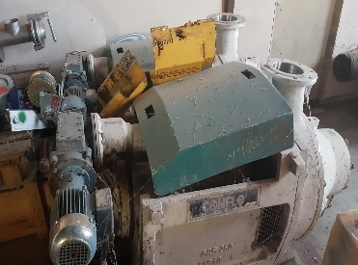
780 | £4,000 | s/c1800052 | screen basket st.st mat.no.1.4436 plate thickness 5.0mm inner dia 412mm height 420mm slot width 0.30mm electro polished incl reinforcing rings! pm2 vat tertiary screen finckh vert rep: | finckh |  | 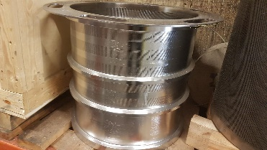
781 | £4,000 | s/c1670507 | screen basket for finckh vertical screen model o. hf no:1188 slot width 0.30mm form b rep: pm1 finckh vertical second stage screen | finckh | model o | 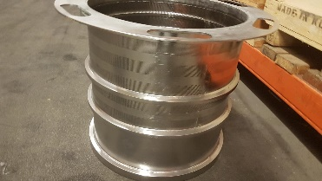
782 | £ 11,000 | s/c1670505 screen basket for vertical screen model k100l 0.30 mm. slot width | screen basket for vertical screen model k100l 0.30 mm. slot width form a. pm1 finckh primary screen model k100l | finckh | k100l | 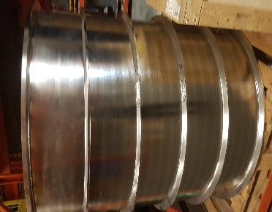
783 | £3,000 | s/c1800049 | screen basket st.st mat.no. 1.4436 plate thickness 5.0mm inner dia 412mm height 420mm slot width 0.25mm electro polished incl reinf[ccing rings *pm2 former second stage screen finckh model h04 | finckh | model h04 | 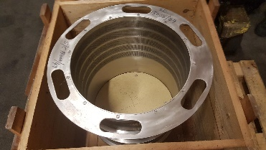
784 | £6,000 | s/c3000300 | screen basket slot width 0.15mm for finckh hico screen model ie hs, hf#245. quote 36.204 (26.6.95) rep: pm3 finckh former secondary screen model ie hs | finckh | model ie hs | 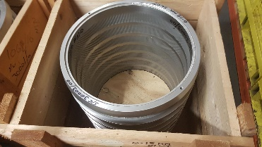
785 | £6,000 | s/c3000100 | screen basket slot width 0.20mm for finckh hico screens model ihs, hf#242 & iehs, hf#243. quote 36.203 (26.6.95) rep: pm3 finckh vat secondary & tertiary screen model ihs & iehs | finckh | model ihs & iehs | 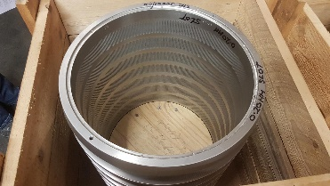
786 | £ 33,000 | s/c1800056 | screen basket st.st mat.no.1.4436 plate thickness 4.0mm inner dia 790mm height 1190mm slot width 0.30mm electro polished incl reinforcing rings rep: pm2 vat primary screens finckh vertical screen model k80l | finckh | model k80l | 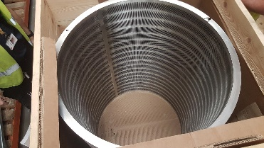
787 | £ 8,000 | s/c1800050 | screen basket st.st mat.no.1.4436 plate thickness 4.0mm inner dia 590mm height 980mm slot width 0.25mm electro polished incl reinforcing rings pm2 former primary screen finckh vertical screen k60l | finckh | screen k60l | 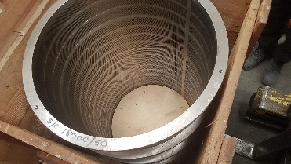
788 | £ 4,000 | s/c1800054 | screen basket st.st mat.no.1.4436 plate thickness 4.0mm inner dia 412mm height 620mm slot width 0.30mm electro polished incl reinforcing rings. rep: pm2 vat second stage screen finckh model k42l | finckh | model k42l | 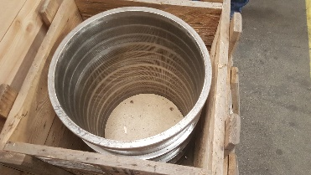
789 | £6,000 | s/c1800008 | cone filling. pattern 'lm' (polished) sunds refiner.jylha jc-01 | sunds | jc 01 lm fillings | 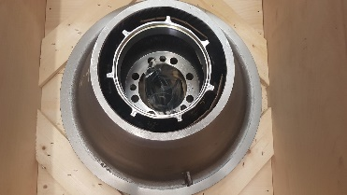
790 | £ 9,000 | s/c1800029 | cone filling tm (polished) rotor:jc01rtm-sjp. stator:jc01stm-sjp. | sunds | jc 01 tm fillings | 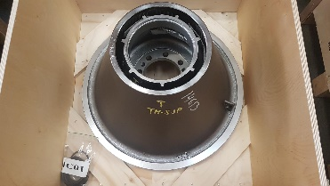
791 | £9,000 | s/c3062003 | cone filling sunds jc01rtc3k - sjp + coating (rotor) jc01stc3k | sunds | jc 01 stc3k fillings | 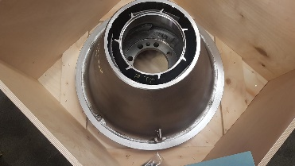
792 | £ 7,000 | s/c1800140 | cone fillings. special sc pattern (every other bar removed) rotor sc.jc01rsch-sj.stator sc.jc01ssch-sj | sunds | jc 01 sc fillings | 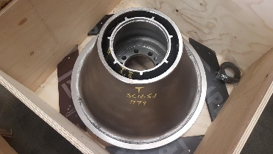
793 | £6,000 | s/c3062200 | cone filling lf for sunds jc-01 refiner comprising rotor & stator | sunds | jc 01 lf fillings | 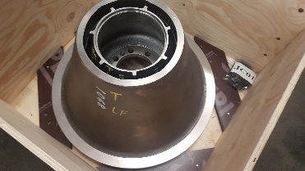
794 | £6,000 | not stock but new | rotor jc01rmm10zsj-cla with stator jc01smm10zsj-cla. | sunds | jc 01 mmz fillings | 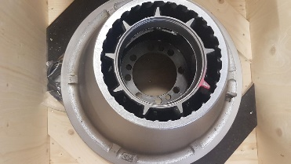
795 | £9,000 | s/c3062003 | cone filling sunds jc01rtc3k - sjp + coating (rotor) jc01stc3k | sunds | jc 01 stc3k fillings | 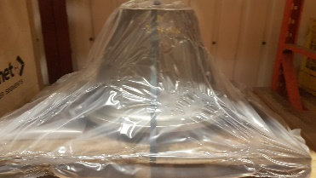
796 | £9,000 | s/c3062003 | cone filling sunds jc01rtc3k - sjp + coating (rotor) jc01stc3k | sunds | jc 01 stc3k fillings
797 | £ 7,000 | s/c1800140 | cone fillings. special sc pattern (every other bar removed) rotor sc.jc01rsch-sj.stator sc.jc01ssch-sj | sunds | jc 01 sc fillings
798 | Box No1  £3,000 | used cones – bar height at 6mm | cone filling lf for sunds jc-01 refiner comprising rotor & stator | sunds | jc 01 lf fillings | 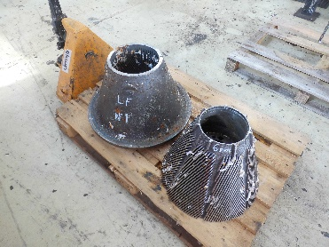
799 | Box No2  £3,000 | used cones – bar height at 10mm | cone filling sunds jc01rtc3k - sjp + coating (rotor) jc01stc3k | sunds | jc 01 stc3k fillings | 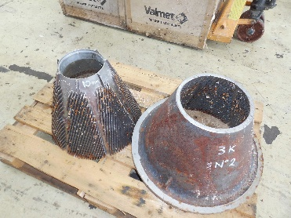
800 | Box No3  £3,000 | used cones – bar height at 6mm | cone filling sunds jc01rtc3k - sjp + coating (rotor) jc01stc3k | sunds | jc 01 stc3k fillings | 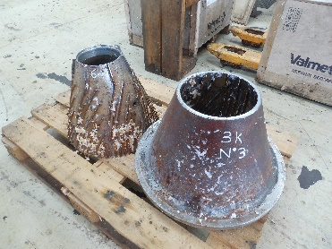
801 | Box No4  £3,000 | used cones – bar height at 6mm | cone fillings. special sc pattern (every other bar removed) rotor sc.jc01rsch-sj.stator sc.jc01ssch-sj | sunds | jc 01 sc fillings | 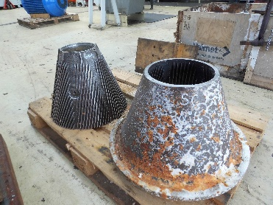
802 | Box No5  £3,000 | used cones – bar height at 7mm | cone filling tm (polished) rotor:jc01rtm-sjp. stator:jc01stm-sjp. | sunds | jc 01 tm fillings | 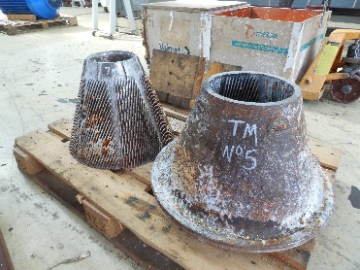
803 | Box No6  £3,000 | used cones – bar height at 8mm | cone filling sunds jc01rtc3k - sjp + coating (rotor) jc01stc3k | sunds | jc 01 stc3 fillings | 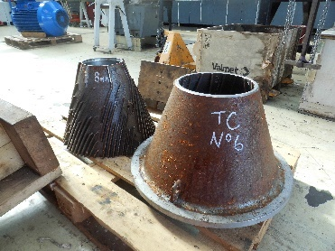
804 | Box No7  £3,000 | used cones – bar height at 8mm | cone fillings. special sc pattern (every other bar removed) rotor sc.jc01rsch-sj.stator sc.jc01ssch-sj | sunds | jc 01 sc fillings | 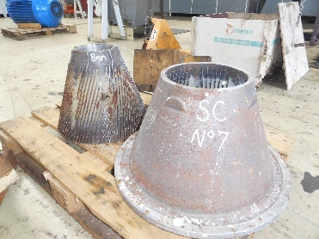
805 | Box No8  £3,000 | used cones – bar height at 8mm | cone filling sunds jc01rtc3k - sjp + coating (rotor) jc01stc3k | sunds | jc 01 stc3k fillings | 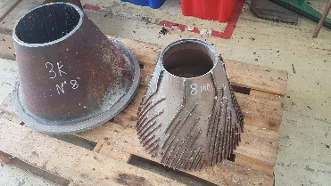
806 | Box No9  £3,000 | used cones – bar height at 7mm | cone fillings. special sc pattern (every other bar removed) rotor sc.jc01rsch-sj.stator sc.jc01ssch-sj | sunds | jc 01 sc fillings | 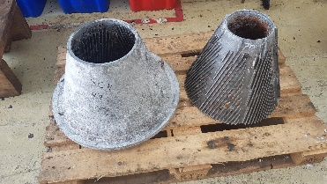
807 | Box No10  £3,000 | used cones – bar height at 8mm | cone fillings. special sc pattern (every other bar removed) rotor sc.jc01rsch-sj.stator sc.jc01ssch-sj | sunds | jc 01 sc fillings | 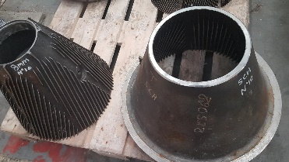
808 | Box No11  £3,000 | used cones – bar height at 8mm | cone filling sunds jc01rtc3k - sjp + coating (rotor) jc01stc3k | sunds | jc 01 stc3k fillings | 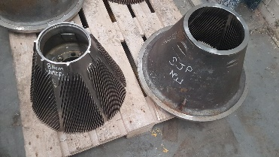
809 | Box No102  £3,000 | used cones – bar height at 7mm | cone fillings. special sc pattern (every other bar removed) rotor sc.jc01rsch-sj.stator sc.jc01ssch-sj | sunds | jc 01 sc fillings | 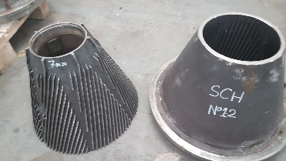
810 | Box No13 | used cones – bar height at 8mm | ?? | sunds | jc 01 sf fillings | 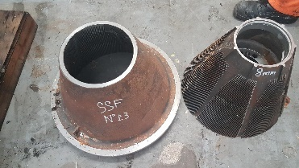
811 | Box No14  £3,000 | used cones – bar height at 5mm | cone filling sunds jc01rtc3k - sjp + coating (rotor) jc01stc3k | sunds | jc 01 stc3k fillings | 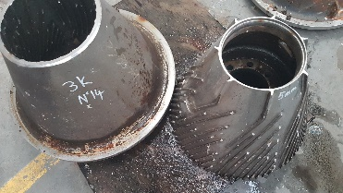
812 | Box No15  £3,000 | used cones – bar height at 11mm | ?? | sunds | jc 01 fillings | 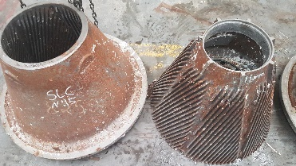
813 | Box No16  £3,000 | used cones – bar height at 7mm | cone filling sunds jc01rtc3k - sjp + coating (rotor) jc01stc3k | sunds | jc 01 stc3k fillings | 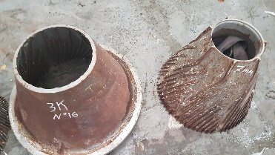
814 | Box No17  £3,000 | used cones – bar height at 10mm | cone filling sunds jc01rtc3k - sjp + coating (rotor) jc01stc3k | sunds | jc 01 stc3k fillings | 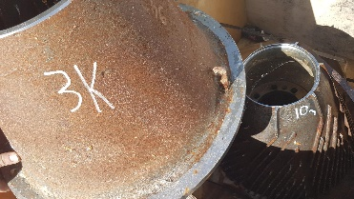
815 | Box No18  £3,000 | used cones – bar height at 4mm very worn | cone fillings. special sc pattern (every other bar removed) rotor sc.jc01rsch-sj.stator sc.jc01ssch-sj | sunds | jc 01 sc fillings | 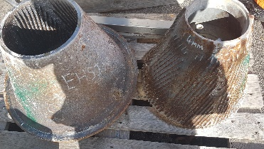
816 | £2,000 | s/c1577905 two sets | discs for 12in. dd refiner 1.062in.thick(new) 0.6875in.(min) no.1 stationery 3.2.3-5 deg. no. 2 rotating 3.2.3.+12.5 deg. no. 3 rotating 3.2.3.+12.5 deg. no. 4 stationery 3.2.3-5deg | jones | disc 12infor d.d.refiner | 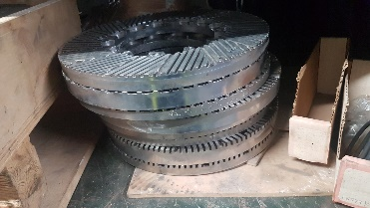
817 | £2,000 | s/c1577933 | discs for jones 14in. double d refiner consisting of no.1 3.2.3 +5 deg. no.2 3.2.3. +15 deg. no.3 3.2.3. +15 deg. no.4 3.2.3. +5 deg. thickness new 1.062in.(min)recut 0.6875 14 in. d.d refiner. recut | jones | disc for jones 14in. dd refiner | 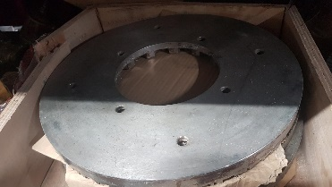
818 | £ 15,000 | s/c1606222 | plug and shell filling.pt.no jcl101rb-sj rotor b for claflin 101 f1 & jcl101sb-sj stator b for claflin b f1 & 426927t bolts (2 off) for claflin f1 8 deg angle **claflin refiners. (650kilo) | valmet technologies | plug & shell filling pt.jcl101rb-sj | 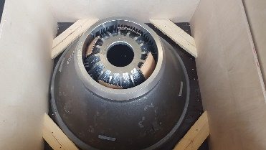
819 | £ 15,000 | non stock | plug and shell filling.pt.no jcl101rb-sj rotor b for claflin 101 f1 & jcl101sb-sj stator b for claflin b f1 & 426927t bolts (2 off) for claflin f1 8 deg angle **claflin refiners. (650kilo) | valmet technologies | plug & shell filling pt.jcl101rb-sj | 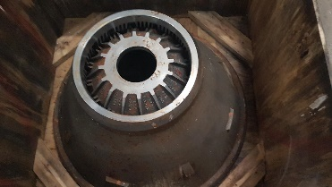
820 | £10,000 | 1810008 | Refiner jylha conflo jc-01 main body | Sunds | JC-01 | 